**Using a Fuzzy Inference System to Determine the Political Leaning of an Area**

IMAT3406 – Fuzzy Logic & Knowledge Based Systems

*Joshua Jackson*

*P16179167*

# **Abstract**

The purpose of this report covers the use of a Fuzzy Inference System in determining which way an area in the UK will lean on the political spectrum. The use of Fuzzy Logic within this domain is limited when compared to more practical domains, despite this, Fuzzy Logic is a perfect candidate as it is a *vague* domain that cannot have definite crisp answers. The system created in this report takes statistics about an area relating to its population density, ethnicity and average salary as well as the number of universities and outputs a degree of membership to a point on the political spectrum (ie. left, right, hard-right etc). The system is biased towards the UK as all of the data used in the design of the system has come from the UK census but the system should be robust enough to adapt to other countries given their population is similar to the UK.

# **Introduction**

Fuzzy Logic is a method of modelling *vagueness* and *uncertainty* wherein the logic is not limited by normal crisp set theory. This report focuses on using fuzzy logic to determine where, on the political spectrum, an area leans given its previous voting history and the statistics about the area and its population. There is limited research of fuzzy logic regarding this application but it is widely used within many other domains from which a review of the literature will outline similarities and whether there is potential for fuzzy logic to accurately determine which way an area is going to lean on the political spectrum given enough data and that the assumptions about that data and how it links to the political spectrum are correct. The system will make use of real-world data gathered from multiple sources including, mainly, the Office for National Statistics **[1, 5].**

The system will be implemented using MATLAB which has a fuzzy logic toolbox allowing for quick iteration and testing alongside the use of Microsoft Excel to record data and expected outputs.

# **Literature Review/Background**

Fuzzy Logic is a method we can apply to situations and domains in which an output is vague or uncertain and where traditional crisp set theory/binary logic isn’t flexible enough **[7]**. Fuzzy Logic is widely used within Electronics (examples include home appliances **[12]** and camera technology **[13]**), Defense (examples include target recognition **[14]**) and Manufacturing (examples include optimisation of food production **[15]**). Whilst fuzzy logic doesn’t have as much of a presence within the political domain, there has been research into the sector by G.F. Royes and R.C. Bastos that looks at how Fuzzy Logic, whilst its use is “seldom questioned in traditional areas like engineering and medicine” still hasn’t been explored as much in fields such as politics where the domain is seen as “only approachable by human experts”. **[8]** Their paper explores the applicability for fuzzy logic in politics and the main approaches are based around the “reelection possibility of a present president, governor or mayor which is usually a target of experts who ponder a set of factors usually obtained through opinion polls” and how fuzzy logic can be applied in much the same manner as the experts are dealing with vague and uncertain scenarios in which fuzzy logic is best applied.

There are many areas in which Fuzzy Logic can be applied to politics outside of just determining which way an area will land on the political spectrum. Some of these include using a fuzzy inference system that uses details about a politician to determine the likelihood they would win an election **[9]**, determining the process a political leader could take when making a decision **[10]** or improving candidate selection within a political party by creating a fuzzy inference system that mimics intuitive decisions about candidate selection **[11]**.

Whilst some of these areas may benefit from the use of a *Sugeno* style system, the most common and well-suited for this application would be the Mamdani style fuzzy system as a Mamdani style system expects the output membership functions to be fuzzy sets **[16]**. This is an important factor as political leaning is perhaps one of the most non-crisp/imprecise outputs where, as opinion polling shows **[17]**, the way in which a person or an area is going to vote is very rarely accurately predicted and almost always varies even within areas where the political leaning is all but confirmed. If the application took the approach of a Sugeno style fuzzy inference system, this would mean the output membership functions are only linear or constant **[16]** making Sugeno a valid application for domains such as an aircraft flight control system **[18]** but less so for determining an output that is itself vague such as which way an area leans on the political spectrum. The research into the use of Fuzzy Logic within politics shows the widespread use of Mamdani style systems, one such example is in the Election Results Prediction System **[9]** where the use of a Sugeno style system is limited and there isn’t much research to be found.

# **System Overview**

## Design Considerations

Due to the nature of the domain in which this fuzzy inference system (FIS) is being applied, the inputs have been chosen largely based on assumptions made regarding *what* influences where an area leans on the political spectrum. An example of an assumption would be the decision to use the “Number of Universities” input, under the assumption that areas with more universities have more students who tend to lean to the left on the political spectrum.

There is only a single system in use that takes 4 inputs instead of having multiple systems as the inputs being used are already crisp values and not something that must be worked out by one FIS to be fed into another.

## The Fuzzy Inference System

The FIS is very simple, it takes 4 inputs and results in a single output.

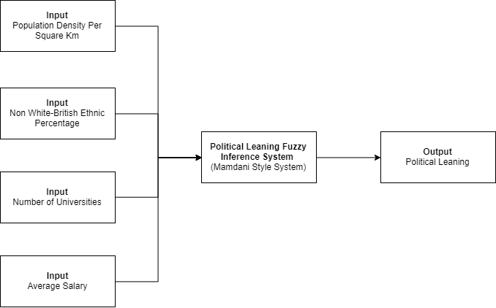

**[Fig 1]:** Diagram of the Political Leaning Fuzzy Inference System

#### Inputs

**Population Density Per Square Km (km2)**

Overall Range: *20 – 17,000/km2*

Membership Points: *Very Low – Low – Medium – High – Very High*

The Population Density Per Square Km lies within the range 20 – 17,000/km2 as this system is based on real data from the UK and, according to the Office for National Statistics, the smallest region by population density (km2) has a density of 25/km2 and the largest a density of 16,097/km2 **[1]**. If this system were to be used outside of the UK in more densely populated areas, this scale may need to be adjusted but in favour of consistency it utilizes an upper and lower range relative to the UK.

**Non White-British Ethnic Percentage (%)**

Overall Range: *0 – 100%*

Membership Points: *Low – Medium – High – Very High*

The Non White-British Ethnic Percentage is the percentage of the population that *do not* identify as White-British in ethnicity. Like the other inputs, this was chosen based on the assumption that it would influence which way an area leans on the political spectrum. It falls within the range 0 – 100% as, although having 100% of an area be non White-British in the UK is incredibly unlikely, the unit of measurement is a percentage and therefore must be kept consistent, allowing it to scale to varying population sizes.

**Number of Universities**

Overall Range: *0 – 40*

Membership Points: *Low – Medium – High – Very High*

The Number of Universities input is exactly as the name suggests, the number of universities within a given area. This input falls within the range 0 – 40 as it is possible for an area to have no universities and the maximum number of universities any region in the UK has is 40 **[2]** which, if it increases, is unlikely to make a difference to the output as it is already very high and very few areas have that many universities.

**Average Salary (£/pa)**

Overall Range: *£13,000 – £100,000*

Membership Points: *Low – Medium – High – Very High*

The final input, Average Salary, is the average yearly salary within a given area. This falls within the range £13,000 - £100,000 as the living wage is £13,000 which is a suitable lower range and although, according to PlumPlot **[3]**, no region’s annual average salary goes above £70,000 having an upper range of £100,000 allows for flexibility and it is unlikely that a rise above that number would make any change to the political leaning output.

#### Output

**Political Leaning**

Overall Range: *0 – 100 (arbitrary unit of measurement)*

Membership Points: *Hard-Left – Left – Centre-Left – Centre – Centre-Right – Right – Hard-Right*

The range used for the Political Leaning output is completely arbitrary and works as a mapping where 0 is completely hard-left and 100 is completely hard-right. Compared to the inputs, this output is complicated as there is a lot of overlap between the different points on the political spectrum but also areas where there shouldn’t be any overlap at all. For example, an area may lean equal parts centre-left and centre on the spectrum, but in that case, they should not be able to lean left on the spectrum. This requires lots of testing to ensure that both the ranges and the membership functions being used clearly outline this whilst also giving accurate results. The testing and evaluation of the output is covered more in the Testing and Evaluation section.

# **Testing and Evaluation**

## The Rulebase

The system features 17 rules all designed to trigger a specific political leaning output depending upon the inputs used.

**Hard-Left:** 1 rule

**Left:** 3 rules

**Centre-Left:** 3 rules

**Centre:** 2 rules

**Centre-Right:** 3 rules

**Right:** 3 rules

**Hard-Right:** 2 rules

These rules can be found in the appendices of the report on **page** **21**

The approach taken when deciding on the rules was to work backwards from a defined output. This meant, for each possible output on the political spectrum, finding a region within the UK that leans that way on the spectrum (this was done using the BBC interactive articles covering which regions voted a certain way in both the 2015 and 2017 general elections **[4]**) and then working backwards by then gathering all of the inputs (Population Density, Non White-British Percentage, Number of Universities and Average Salary (found using census data and various other sources **[5][6]**) and noting their point of membership, this could then be made into a rule where, when plugging in the data used in creating the rule, we should expect the outcome that we started with. This method was favoured over creating rules for every possible combination as it provided a definite output that can be tested against, it also resulted in the rulebase being realistic; For example, there are more regions in the UK that are Left, Centre-Left and Centre-Right, Right than there are Hard-Left and Hard-Right and the rulebase reflects this. A possible approach to that could have been to have the same number of rules for every output and then weight the less likely outcomes down, but the way in which the rulebase was decided resulted in this happening naturally.

## Refining the Inputs

The system initially started with 3 inputs, these were *Population*, *Foreign Population Percentage* and *Number of Universities*. This worked as expected for the first region, Leicester, where I worked backwards from a Centre-Left output by gathering the statistics and creating a rule on the assumption that the statistics for Leicester would lead to a Centre-Left output. I then carried out the same process for various other regions and started to discover a few issues with my inputs:

First and foremost, I found that using Population as an indicator effectively limited the system to areas of a similar size as trying to fit smaller areas which obviously had smaller populations onto the population scale meant that they all fit under the *Low* section when it came to population. To help the system scale better I decided to swap Population for Population Density as this scaled no matter the size of the population.

Secondly, I found that my Foreign Population Percentage input wasn’t to scale, I had 100% as “High” where realistically no area had that high of a foreign population and the highest I was seeing through research was around 40% so I added an extra membership function called “very high” and then shifted all of the values along so that they coincided with reality, this instantly gave my outcomes a much more realistic score. Despite this change, whilst gathering data for testing I found it incredibly difficult to find data on many regions regarding what their Foreign Population Percentage was and so decided it would make more sense to switch this input to *Non White-British Ethnic Percentage* which is very similar expect data is more abundant and the differences between regions is much larger allowing for a more refined rulebase.

Whilst creating more rules I found that I was severely limited by having only 3 inputs. The way around this was to add another input which would allow me to create more rules and from my research the two options were Average Age and Average Salary within a region. I checked the statistics using PlumPlot **[3]** for as many regions as possible and it turned out that the average age didn’t vary much between regions with most regions having the same average; The average salary, however, varied a lot in different places so I figured it would be the better input.

Through testing I realised that for some of my membership functions I wasn’t counting the apex of that membership function to be the highest degree of membership which led to some unusual results such as an area with 0 universities not counting as an area with a Low number of universities as the triangular membership function used [0 2 4] instead of [-4 2 4] which meant that 0 didn’t even trigger the function.

## Refining the Output

Through my initial experimentation I found that the political leaning output featured a lot of overlap between the Left and Right spectrums whereas you would expect that if a region leans centre-left, they shouldn’t have the ability to overlap with hard-left as this would require them to be a member of left. I shifted the values that each membership function used to ensure that this wasn’t a viable overlap. As you can see in **[Fig 2]** the membership functions feature very little overlap whereas in **[Fig 6]** you can see how problematic the previous iteration was.

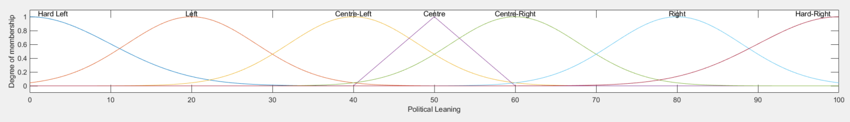

**[Fig 2]** Plot showing all the membership functions for the Political Leaning output after adjustments

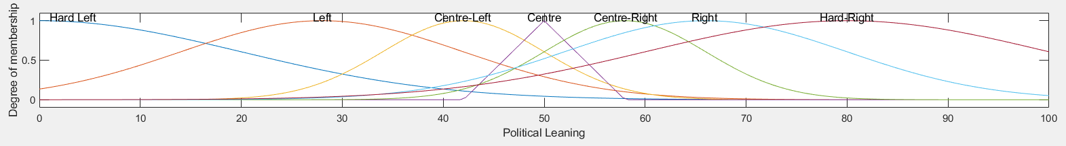

**[Fig 6]** Plot showing all the membership functions for Political Leaning Output before adjustments

## Testing Defuzzification Methods

**Centroid**

|  |  |  |  |  |  |
| --- | --- | --- | --- | --- | --- |
| **Population Density** | **Non White-British Ethnic Percentage** | **Number of Universities** | **Average Salary** | **Expected Output** | **Actual Output** |
| 3679 | 21.1 | 2 | 39500 | Centre-Right (52 - 68) | 42.79 |
| 3270 | 36 | 3 | 38800 | Centre-Right (52 – 68) | 59.98 |
| 12210 | 33.3 | 3 | 32500 | Left (12 - 28) | 43.37 |
| 10070 | 9 | 3 | 33700 | Left (12 – 28) | 26.27 |

**[Fig 3]** Table showing 4 cherry picked inputs and their expected and actual outputs using centroid.

As you can see in **[Fig 3]** there are two data sets that we expect to give us a Centre-Right output and two data sets that we expected to give us a Left output. In both cases there is one test that passes and one that fails. These are cherry picked tests, in the actual tests I used 17 data sets matching the rules that had been created (these can be found in the appendices on **pages 18, 19 and 20**), and out of that 17, 6 of them didn’t produce the expected output (2 of which have been cherry picked). These results shouldn’t be happening if we look at the rulebase as the rule that should be triggered for the specified set of inputs was created by working backwards for that output specifically matching it to those inputs so we must first look at our defuzzification method. On the first pass I was making use of the Centroid defuzzification method which obviously didn’t provide perfect results, so I decided to try out some of the other built in defuzzification methods.

**Bisector**

|  |  |  |  |  |  |
| --- | --- | --- | --- | --- | --- |
| **Population Density** | **Non White-British Ethnic Percentage** | **Number of Universities** | **Average Salary** | **Expected Output** | **Actual Output** |
| 3679 | 21.1 | 2 | 39500 | Centre-Right (52 - 68) | 44 |
| 3270 | 36 | 3 | 38800 | Centre-Right (52 – 68) | 60 |
| 12210 | 33.3 | 3 | 32500 | Left (12 - 28) | 47 |
| 10070 | 9 | 3 | 33700 | Left (12 – 28) | 24 |

**[Fig 4]** Table showing 4 cherry picked inputs and their expected and actual outputs using bisector.

As you can see in **[Fig 4]**, using the Bisector defuzzification method made it so that the outputs that met their expectations whilst using Centroid were even closer to the highest degree of membership whilst using Bisector but the outputs that failed to meet their expectations were even further away. This pattern was the same throughout all the test results.

**MOM**

|  |  |  |  |  |  |
| --- | --- | --- | --- | --- | --- |
| **Population Density** | **Non White-British Ethnic Percentage** | **Number of Universities** | **Average Salary** | **Expected Output** | **Actual Output** |
| 3679 | 21.1 | 2 | 39500 | Centre-Right (52 - 68) | 50 |
| 3270 | 36 | 3 | 38800 | Centre-Right (52 – 68) | 60 |
| 12210 | 33.3 | 3 | 32500 | Left (12 - 28) | 50 |
| 10070 | 9 | 3 | 33700 | Left (12 – 28) | 20 |

**[Fig 5]** Table showing 4 cherry picked inputs and their expected and actual outputs using MOM.

As you can see in **[Fig 5]**, MOM hasn’t fixed the issue we are facing with the failing data sets, only slight adjustments to be seen and not always an improvement.

**LOM and SOM**

Testing the same data with the LOM and SOM defuzzification methods didn’t produce expected results, LOM made every output way higher than their expected output and SOM produced similar results to MOM.

## Testing and Refining the Rulebase

Experimenting with the defuzzification methods showed that it must be the rulebases that are at fault as no large change occurred in the right direction when switching methods. So the next approach was to tackle the problem rule by rule; Each data set was made for a specific rule as the output was used to work backwards and create the rule using the data for that area. With the faulty rules, I started by experimenting with the operator (changing from AND to OR), this got me closer to the expected outcome but not enough to point to the operator being the issue. For the first of the faulty data sets, I used the rule view to see what was being triggered and it showed that one of the centre-right rules was clashing with a centre-left rule as the only differentiator was the average salary input. On first glance this seemed to be an issue, but upon further research it was the expected outcome, just not the expected outcome I had initially wrote down. I therefore removed the data set as it didn’t conform to the rule that was created because of it.

Whilst using the rule view I found that some of the issues came from having an extra rule for the hard-right output whilst only having a single rule for the hard-left output despite the latter being more common, this skewed the spectrum to the right more than was expected, removing the offending rule and balancing out the rulebase not only improved the data set that made me aware of the issue, but also meant data sets that should have been centre-left but previous leaned more to the centre eventually shifted back to centre-left.

The final troublesome data set revealed itself in the ruleview as none of the rules were being triggered which led it to being placed in the centre-left point instead of the expected left point. I shifted the operator for the rule to OR and this put it exactly where it needed to be, but it also shifted every other output to the left which wasn’t the desired result. Investigating further I realized that the two data sets were in the wrong place, probably an error when inputting, I swapped them around which led to them conforming to their relevant rules.

A big proponent to the issues I faced was that the data had been inputted wrong or attributed to an irrelevant rule. The use of the rule view within MATLAB allowed me to see these mistakes quite easily, especially in the cases where inputs triggered a totally different rule as it pointed me to the exact rule that was being triggered and which input[s] caused it to be triggered.

All in all, I removed 2 data sets from the base test data as these didn’t match a specific rule that was created because of them and removed a single rule from hard-right as it was skewing the output as there is only a single hard-left rule. This led to a more robust rulebase.

# **Critical Reflection**

Due to the nature of the domain in which the system was being applied, assumptions had to be made about *what* affects the way in which an area leans on the political spectrum, there is no scientific grounding for the assumption that Population Density, Non White-British Ethic Population Percentage, Number of Universities and Average Salary all have an effect on political leaning; With that in mind, the system was able to produce accurate results (judged by an area’s past voting record **[4]**) from the data that was provided as inputs. In its rudimentary state, although accurate within the range of inputs used, the system probably cannot be used in situations where real accuracy is important as this would require many more inputs and finer detail paid to the nuances associated with politics and political leaning; The system can, however, be used within less serious situations such as within Video Games that feature the simulation of political leaning where accuracy isn’t important, but the use of a fuzzy system instead of randomly assigning political leaning would add more depth to the game or simulation.

The system could have been drastically improved via the use of many more inputs as well as the assumptions being backed up by extensive research into political science however this was out of the scope for this project/report as the focus was on the fuzzy inference system itself rather than the assumptions made. The system could also have been made to scale much better by being nation-agnostic; In its current state the system is heavily biased towards the UK, using other countries and their political systems would most definitely add to the depth of the system but would most likely also increase the complexity although an argument could be made for sticking within one political system for consistency.

Up until the testing phase, the performance of the system was heavily based on assumptions but during testing many issues were uncovered and the performance of the system could be tweaked by adjusting actual problem areas and seeing tangible results. One of the biggest areas where testing revealed there could be an improvement made was that, for such an uncertain domain where boundaries are very loose, it would have helped to increase the number of membership points for any given input. The maximum number of membership points an input had was Population Density with 5 and every other input had 4. This could be improved by creating as many points of membership as possible to allow for a more fine-grained output as well as a more refined rulebase where no issues occur due to rule crossover despite being on different ends of the spectrum.

# **Conclusion**

In summary, working on this project has taught me a lot about fuzzy logic, something I didn’t know existed until now, and about the different ways that politics is approached by both experts and the systems experimented with in the hopes of, at least partially, replacing those experts. This project/report serving as an introduction, I will be making use of fuzzy logic and the concepts I have discussed within this report in the future. It was a challenge, albeit a very rewarding challenge, to develop a system based on real-world data that had the aim of producing accurate results about such an uncertain topic but the use of MATLAB allowed me to explore the underlying ideas without worrying about low-level implementation details, the next logical step would be to reproduce this system within other high-level languages wherever applicable.

If I could restart the process over again, I would first research more deeply into what effects political leaning so that, even in such a basic state, the system could have real-world usage based on expert opinion and research. Overall, I believe this report showcases that fuzzy logic has an application within this area of politics given its very nature is vague and uncertain and with some detailed research it could help make actual real-world decisions both in the short term (*politicians decide what issues to campaign for in an area based on how an area is predicted to lean)* and the long term (*governments making actual changes in those areas in order to shift their leaning on the political spectrum*).

# **Bibliography**

1. Office for National Statistics: Estimates of the population for the UK, England and Wales, Scotland and Northern Ireland <https://www.ons.gov.uk/peoplepopulationandcommunity/populationandmigration/populationestimates/datasets/populationestimatesforukenglandandwalesscotlandandnorthernireland>
2. Higher Education Providers in the UK <https://www.hesa.ac.uk/support/providers>
3. England and Wales Salary Per Annum by Postcode Area <http://www.plumplot.co.uk/salary-and-unemployment.html>
4. BBC General Election 2015/2017 results <https://www.bbc.co.uk/news/election/2015/results> / <https://www.bbc.co.uk/news/election/2017/results/england>
5. 2011 Census Data <http://www.nomisweb.co.uk/census/2011/bulk/r2_2>
6. The Migration Observatory – Migration in the Census <https://migrationobservatory.ox.ac.uk/projects/migration-in-the-census/>
7. Geometric Fuzzy Logic Systems by Simon Coupland and Robert John -<https://dora.dmu.ac.uk/handle/2086/10782> [Last Accessed: 02/12/19]
8. Fuzzy Sets in Political Science by G.F. Royes and R.C. Bastos - <https://ieeexplore-ieee-org.proxy.library.dmu.ac.uk/document/944730> [Last Accessed: 02/12/19]
9. Election Results Prediction System based on Fuzzy Logic by Harmanjit Singh, Gurdev Singh and Nitin Bhatia - <https://www.ijcaonline.org/archives/volume53/number9/8450-2245> [Last Accessed: 02/12/19]
10. Fuzzy Decision Making in Politics: A Linguistic Fuzzy-Set Approach (LFSA) by Badredine Arfi- <https://www.researchgate.net/publication/31402550_Fuzzy_Decision_Making_in_Politics_A_Linguistic_Fuzzy-Set_Approach_LFSA> [Last Accessed: 02/12/19]
11. A Proposed Model for Candidate Selection Process in Political Parties Based on Fuzzy Logic Methodology by Yılmaz Gökşen, Onur Doğan and Mete Eminağaoğlu - <https://www.mdpi.com/2297-8747/17/2/152> [Last Accessed: 02/12/19]
12. Application of fuzzy logic in home appliance: gas heater controller design by Zhu Rongming, Tian Bian, Wang Qiantu and Dai Guaozhong - <https://ieeexplore-ieee-org.proxy.library.dmu.ac.uk/document/672803> [Last Accessed: 02/12/19]
13. Enhanced Autofocus Algorithm Using Robust Focus Measure and Fuzzy Reasoning by Sang-Yong Lee, Yogendera Kumar, Ji-Man Cho, Sang-Won Lee, Soo-Won Kim - <https://ieeexplore-ieee-org.proxy.library.dmu.ac.uk/document/4498431> [Last Accessed: 02/12/19]
14. Radar target recognition Fuzzy Logic by M. Moruzzis and N. Colin - <https://ieeexplore-ieee-org.proxy.library.dmu.ac.uk/document/690808> [Last Accessed: 02/12/19]
15. Fuzzy Logic Approach for Process Optimization of Gluten-Free Pasta by Nilesh Sakre, Amit B. Das and Prem P. Srivastav - <http://search.ebscohost.com.proxy.library.dmu.ac.uk/login.aspx?direct=true&AuthType=ip,shib&db=bth&AN=118513456&site=ehost-live> [Last Accessed: 02/12/19]
16. Designing and Modeling Solar Energy Systems by Soteris A. Kalogirou - <https://www.sciencedirect.com/topics/engineering/fuzzy-inference> [Last Accessed: 02/12/19]
17. Election Polling by The Pew Research Center - <https://www.pewresearch.org/methods/u-s-survey-research/election-polling/> [Last Accessed: 02/12/19]
18. Survey of Gain-Scheduling Analysis & Design by D.J Leith and WE.Leithead - <http://mural.maynoothuniversity.ie/1834/1/1001965764_link_19992.pdf> [Last Accessed: 02/12/19]

# **Appendix**

## **Pre-Testing System Design in MATLAB**

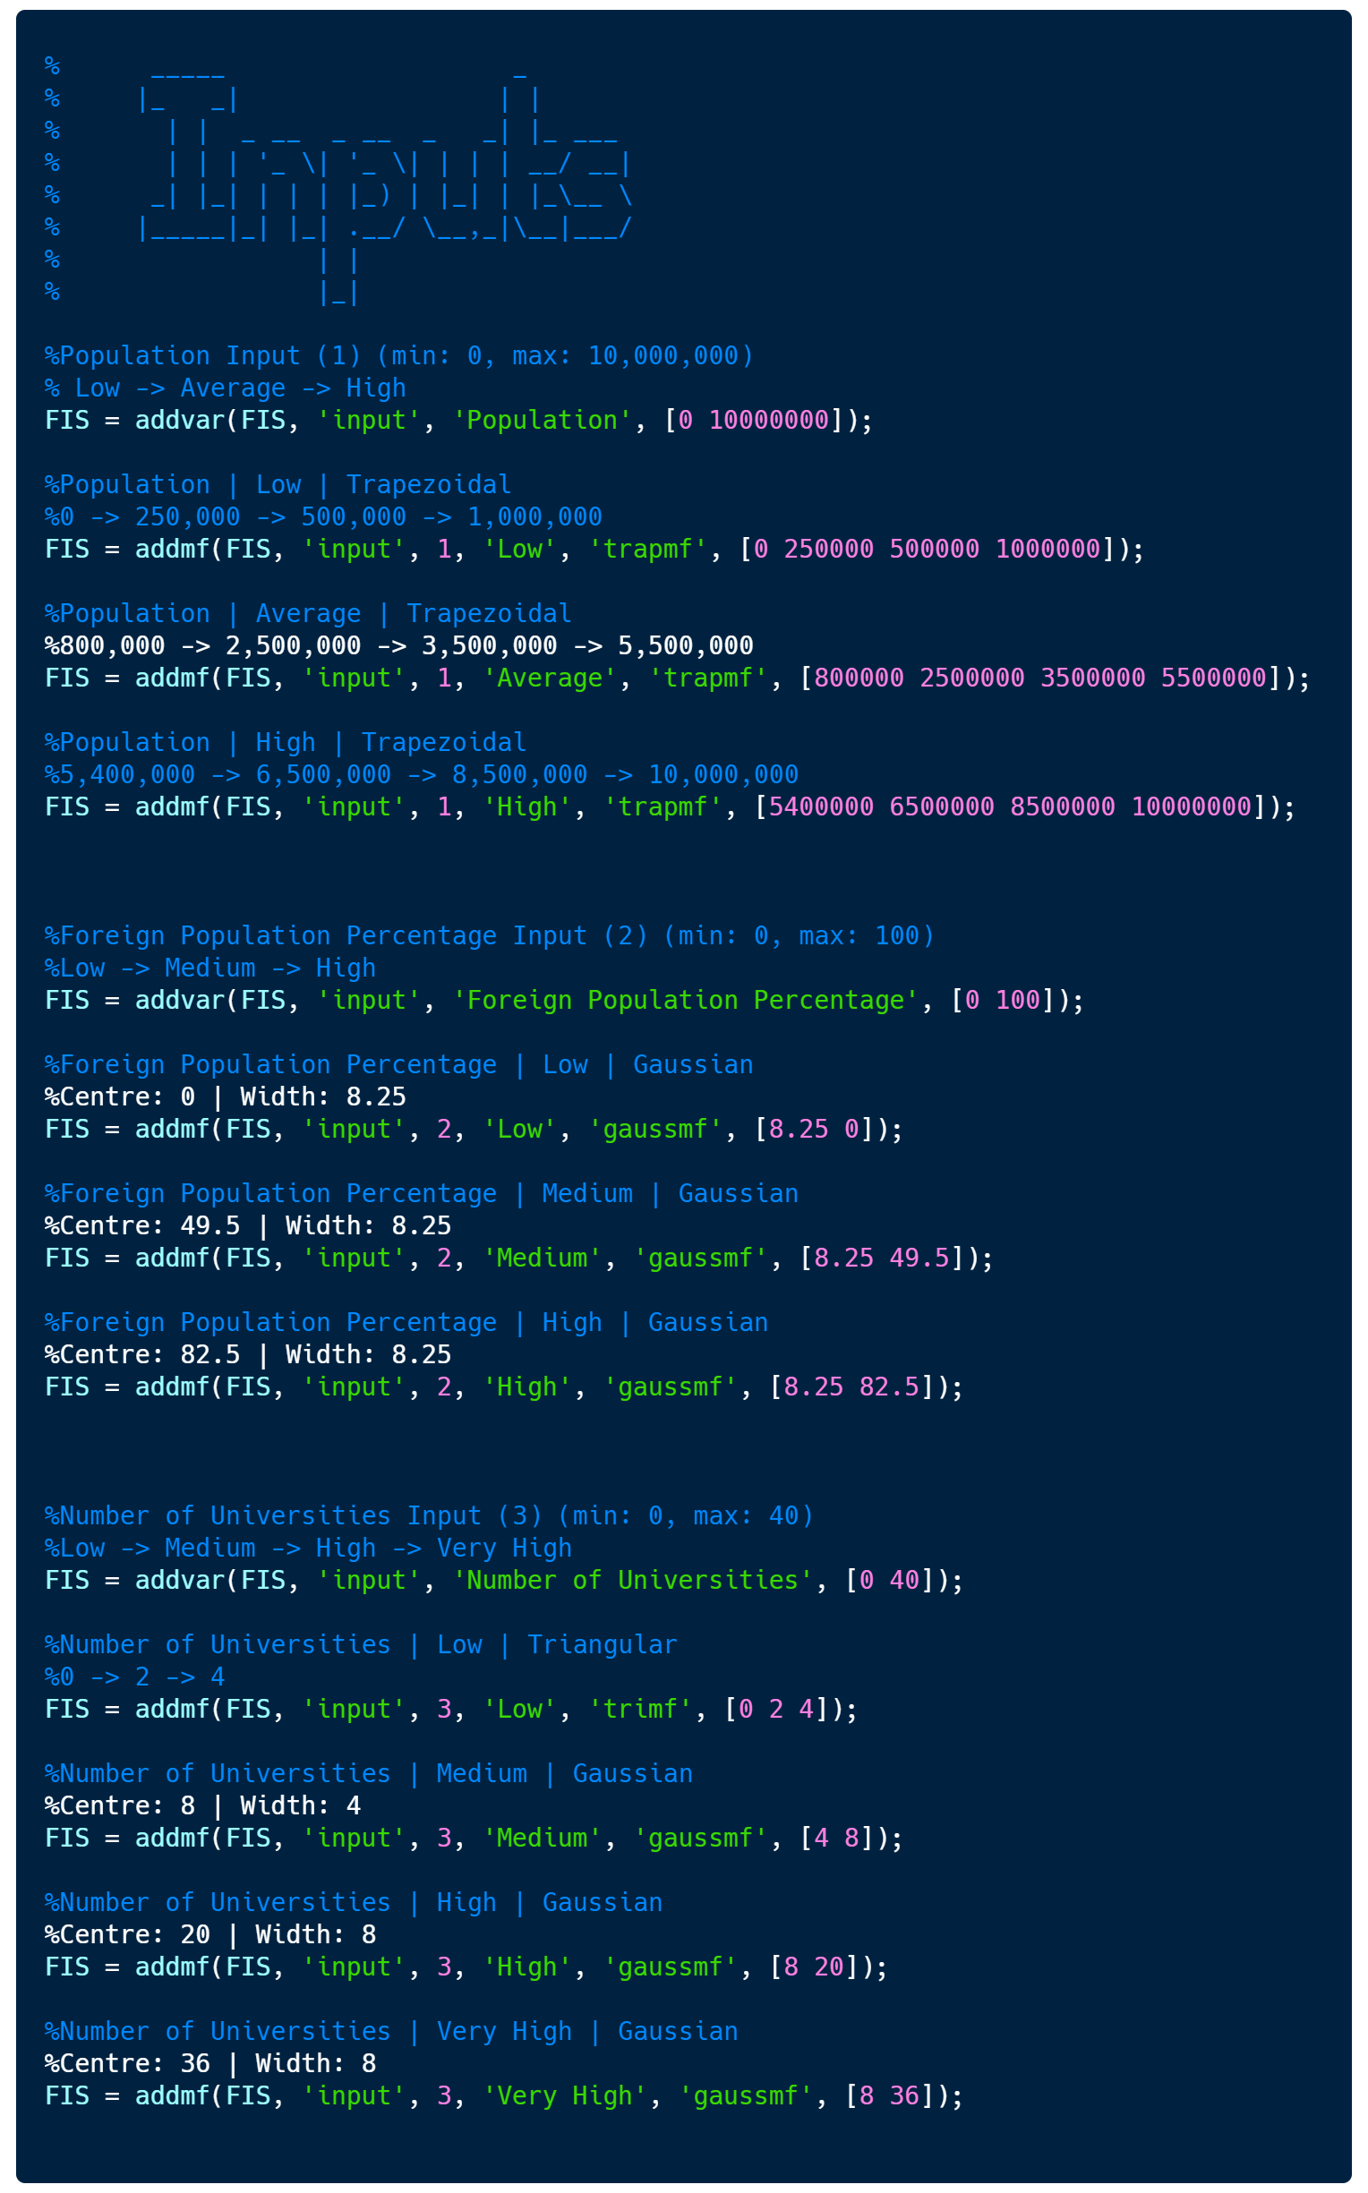

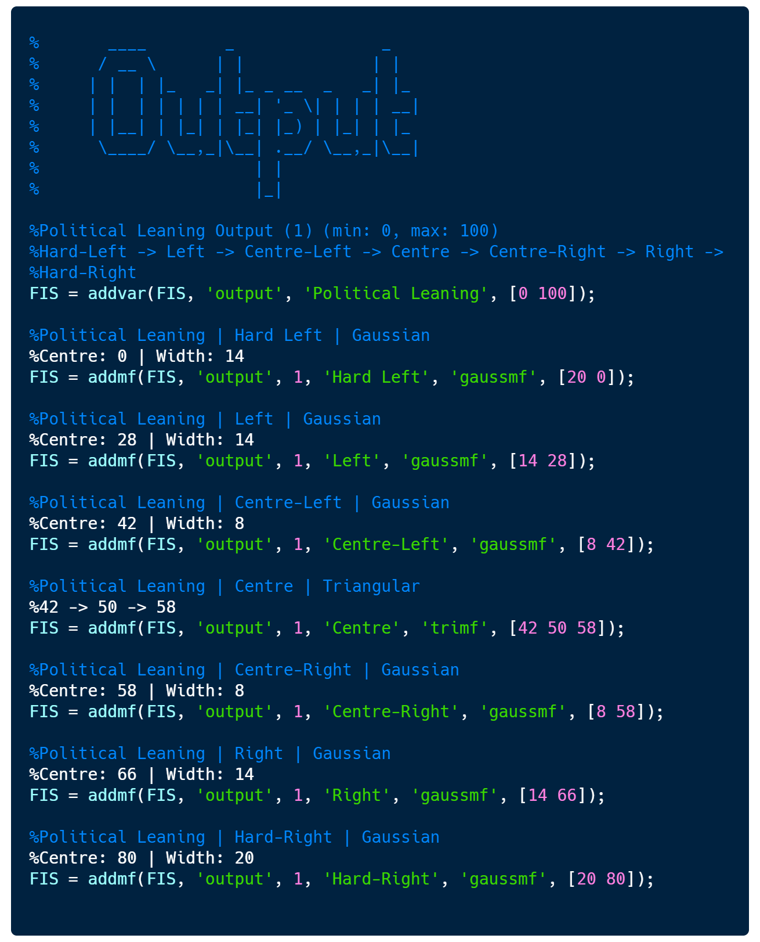

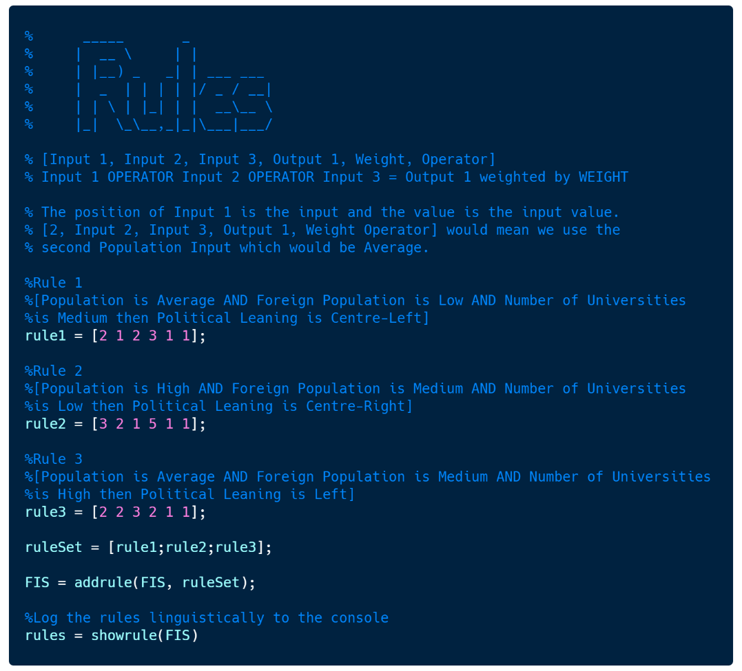

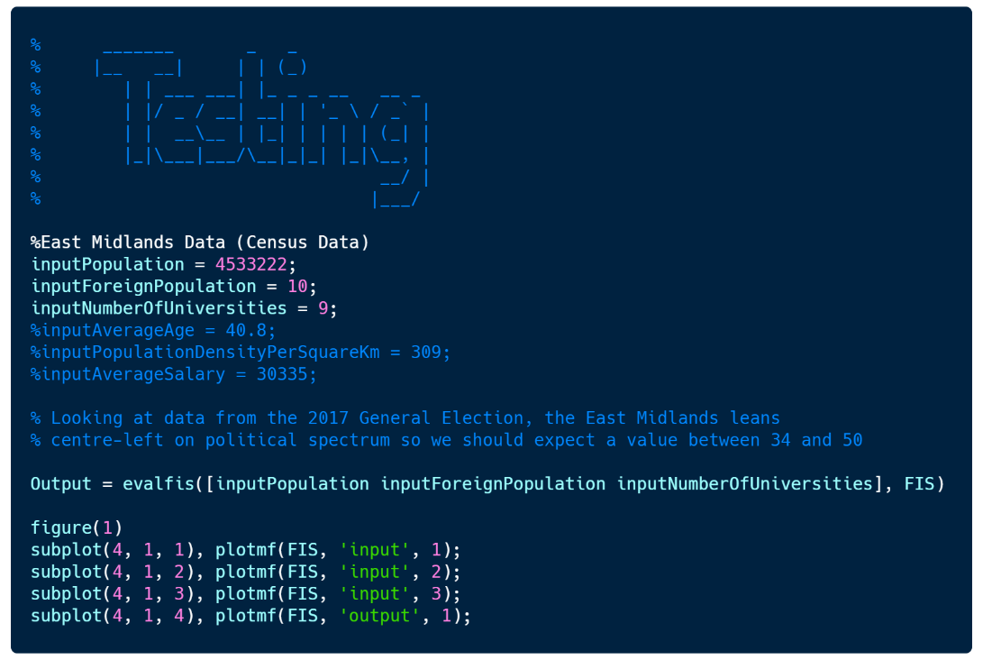

## **Post-Testing System Design in MATLAB**

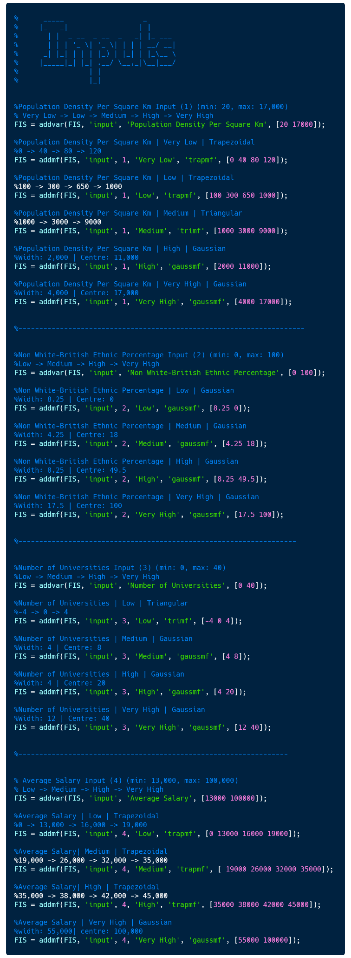

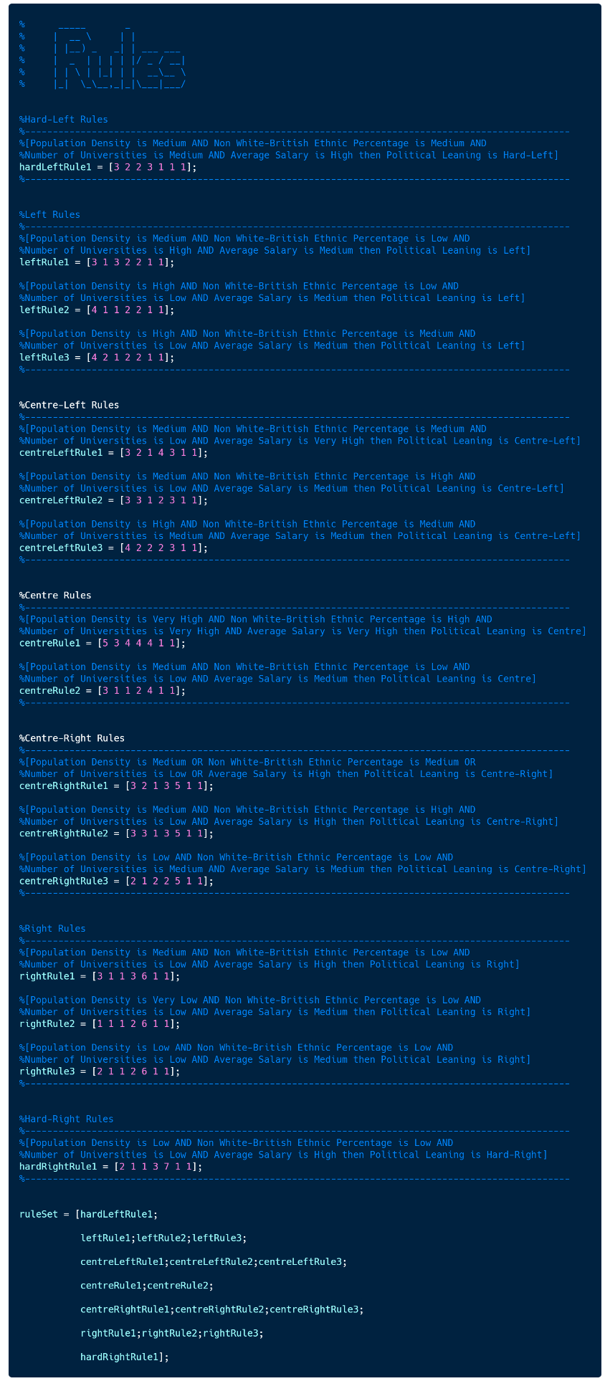

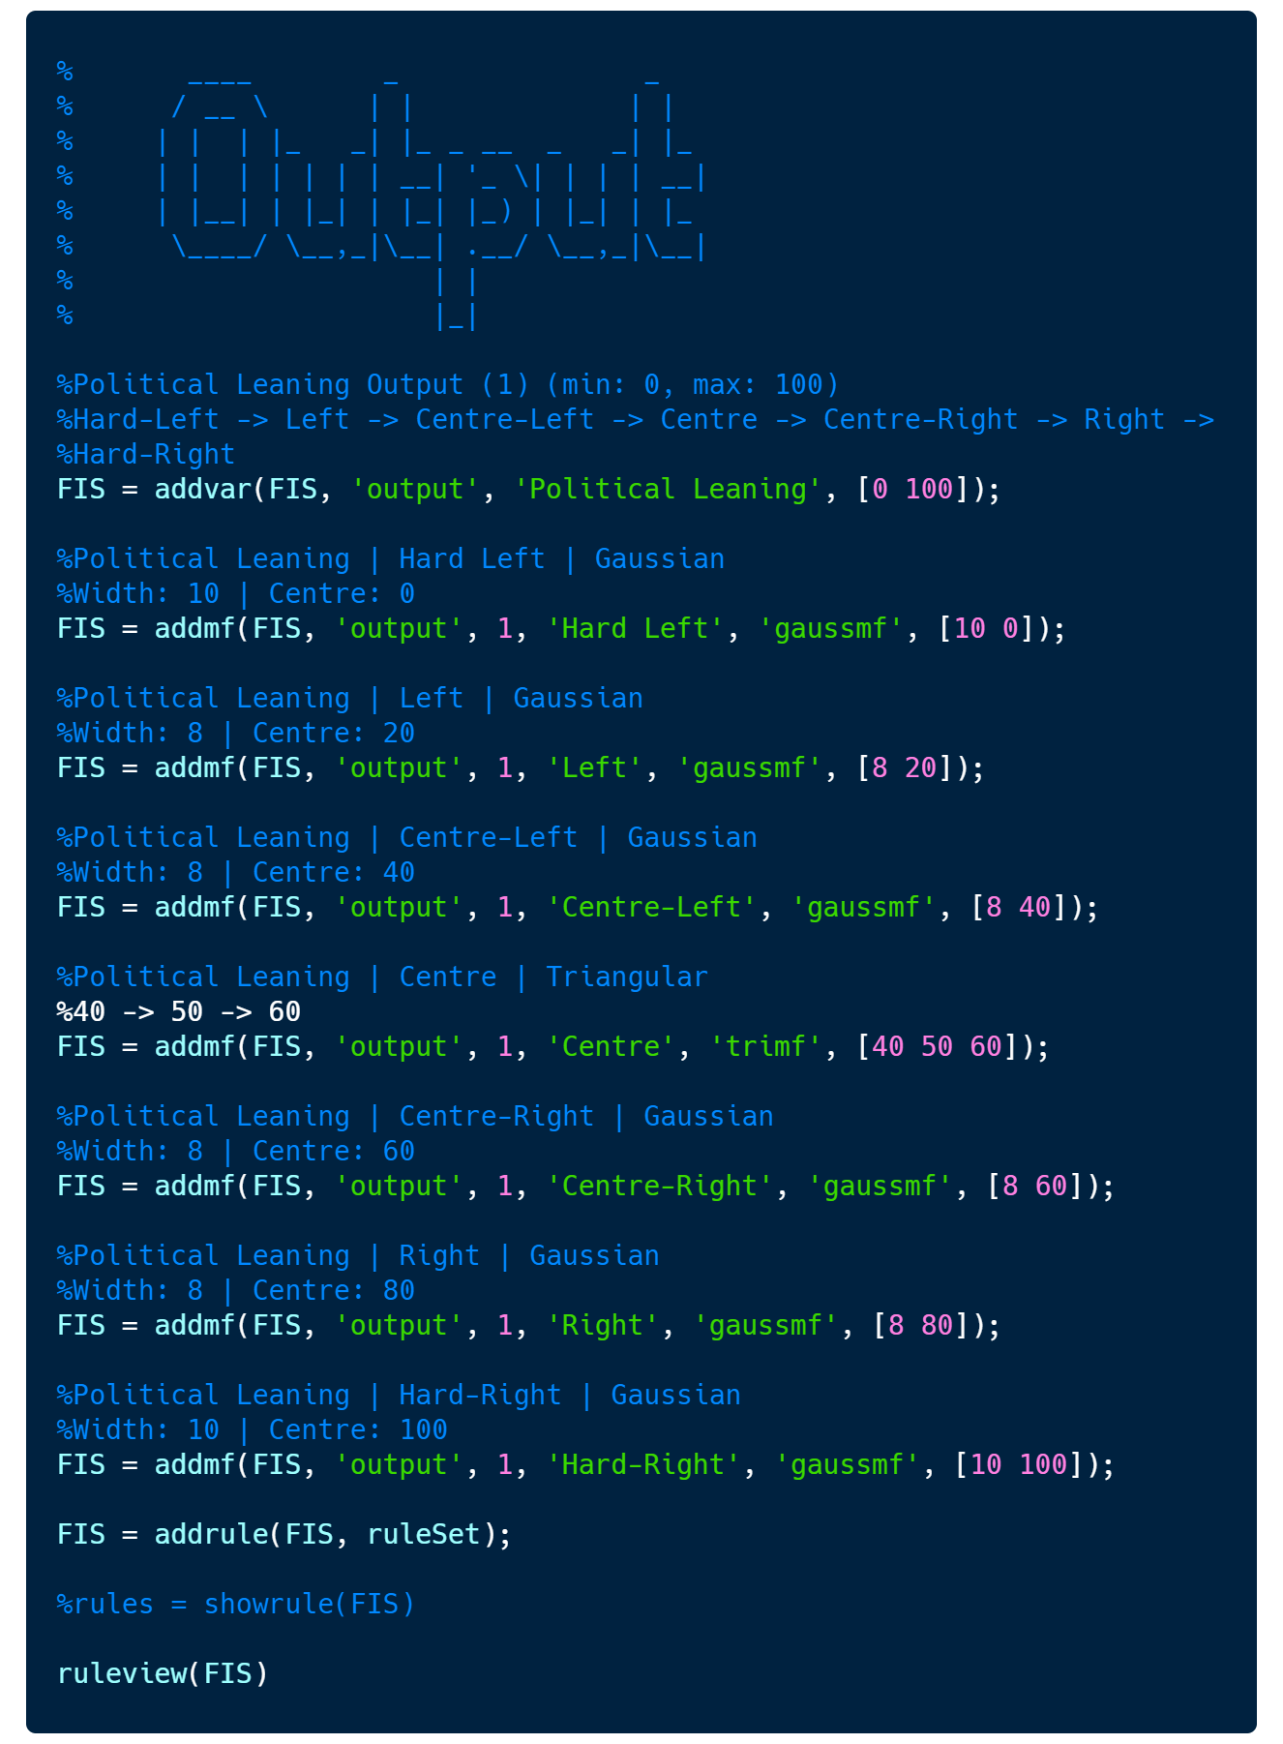

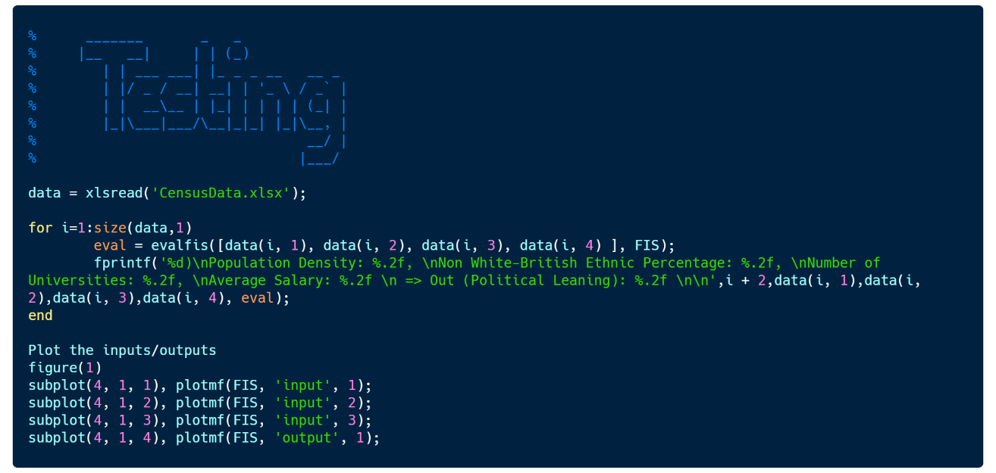

## Test Data

**Centroid**

|  |  |  |  |  |
| --- | --- | --- | --- | --- |
| **Population Density Per Square Km** | **Non White-British Ethnic Percentage** | **Number of Universities** | **Average Salary** | **Output (Political Leaning)** |
|  |  |  |  |  |
| 3270 | 36 | 3 | 38800 | 59.98357486 |
| 4040 | 34.7 | 1 | 37400 | 59.92550499 |
| 489 | 11 | 4 | 33000 | 59.99991496 |
| 4000 | 2.25 | 2 | 36500 | 79.62955386 |
| 73 | 4.9 | 1 | 28300 | 79.86702472 |
| 372 | 2.7 | 0 | 27500 | 76.35341463 |
| 499 | 9.2 | 2 | 40000 | 90.73472028 |
| 3135 | 26.5 | 2 | 44600 | 40.04876348 |
| 4495 | 55 | 2 | 30000 | 40.00001206 |
| 9450 | 15 | 8 | 34900 | 40.00010888 |
| 3400 | 11.7 | 10 | 26400 | 21.56889543 |
| 10070 | 9 | 3 | 33700 | 26.27430446 |
| 8500 | 7.1 | 3 | 30000 | 25.29404051 |
| 3000 | 19.5 | 6 | 39000 | 7.96403433 |
| 14550 | 55.1 | 40 | 65000 | 50 |
| 12210 | 33.3 | 3 | 32500 | 43.37133616 |

**Bisector**

|  |  |  |  |  |
| --- | --- | --- | --- | --- |
| **Population Density Per Square Km** | **Non White-British Ethnic Percentage** | **Number of Universities** | **Average Salary** | **Output (Political Leaning)** |
|  |  |  |  |  |
| 3270 | 36 | 3 | 38800 | 60 |
| 4040 | 34.7 | 1 | 37400 | 60 |
| 489 | 11 | 4 | 33000 | 60 |
| 4000 | 2.25 | 2 | 36500 | 80 |
| 73 | 4.9 | 1 | 28300 | 80 |
| 372 | 2.7 | 0 | 27500 | 79 |
| 499 | 9.2 | 2 | 40000 | 91 |
| 3135 | 26.5 | 2 | 44600 | 40 |
| 4495 | 55 | 2 | 30000 | 40 |
| 9450 | 15 | 8 | 34900 | 40 |
| 3400 | 11.7 | 10 | 26400 | 21 |
| 10070 | 9 | 3 | 33700 | 24 |
| 8500 | 7.1 | 3 | 30000 | 23 |
| 3000 | 19.5 | 6 | 39000 | 7 |
| 14550 | 55.1 | 40 | 65000 | 50 |
| 12210 | 33.3 | 3 | 32500 | 47 |

**MOM**

|  |  |  |  |  |
| --- | --- | --- | --- | --- |
| **Population Density Per Square Km** | **Non White-British Ethnic Percentage** | **Number of Universities** | **Average Salary** | **Output (Political Leaning)** |
|  |  |  |  |  |
| 3270 | 36 | 3 | 38800 | 60 |
| 4040 | 34.7 | 1 | 37400 | 60 |
| 489 | 11 | 4 | 33000 | 60 |
| 4000 | 2.25 | 2 | 36500 | 80 |
| 73 | 4.9 | 1 | 28300 | 80 |
| 372 | 2.7 | 0 | 27500 | 80 |
| 499 | 9.2 | 2 | 40000 | 94.5 |
| 3135 | 26.5 | 2 | 44600 | 40 |
| 4495 | 55 | 2 | 30000 | 40 |
| 9450 | 15 | 8 | 34900 | 40 |
| 3400 | 11.7 | 10 | 26400 | 20 |
| 10070 | 9 | 3 | 33700 | 20 |
| 8500 | 7.1 | 3 | 30000 | 20 |
| 3000 | 19.5 | 6 | 39000 | 2.5 |
| 14550 | 55.1 | 40 | 65000 | 50 |
| 12210 | 33.3 | 3 | 32500 | 50 |

**LOM**

|  |  |  |  |  |
| --- | --- | --- | --- | --- |
| **Population Density Per Square Km** | **Non White-British Ethnic Percentage** | **Number of Universities** | **Average Salary** | **Output (Political Leaning)** |
|  |  |  |  |  |
| 3270 | 36 | 3 | 38800 | 73 |
| 4040 | 34.7 | 1 | 37400 | 74 |
| 489 | 11 | 4 | 33000 | 70 |
| 4000 | 2.25 | 2 | 36500 | 89 |
| 73 | 4.9 | 1 | 28300 | 86 |
| 372 | 2.7 | 0 | 27500 | 82 |
| 499 | 9.2 | 2 | 40000 | 100 |
| 3135 | 26.5 | 2 | 44600 | 56 |
| 4495 | 55 | 2 | 30000 | 49 |
| 9450 | 15 | 8 | 34900 | 60 |
| 3400 | 11.7 | 10 | 26400 | 40 |
| 10070 | 9 | 3 | 33700 | 33 |
| 8500 | 7.1 | 3 | 30000 | 33 |
| 3000 | 19.5 | 6 | 39000 | 5 |
| 14550 | 55.1 | 40 | 65000 | 52 |
| 12210 | 33.3 | 3 | 32500 | 59 |

**SOM**

|  |  |  |  |  |
| --- | --- | --- | --- | --- |
| **Population Density Per Square Km** | **Non White-British Ethnic Percentage** | **Number of Universities** | **Average Salary** | **Output (Political Leaning)** |
|  |  |  |  |  |
| 3270 | 36 | 3 | 38800 | 47 |
| 4040 | 34.7 | 1 | 37400 | 46 |
| 489 | 11 | 4 | 33000 | 50 |
| 4000 | 2.25 | 2 | 36500 | 71 |
| 73 | 4.9 | 1 | 28300 | 74 |
| 372 | 2.7 | 0 | 27500 | 78 |
| 499 | 9.2 | 2 | 40000 | 89 |
| 3135 | 26.5 | 2 | 44600 | 24 |
| 4495 | 55 | 2 | 30000 | 31 |
| 9450 | 15 | 8 | 34900 | 20 |
| 3400 | 11.7 | 10 | 26400 | 0 |
| 10070 | 9 | 3 | 33700 | 7 |
| 8500 | 7.1 | 3 | 30000 | 7 |
| 3000 | 19.5 | 6 | 39000 | 0 |
| 14550 | 55.1 | 40 | 65000 | 48 |
| 12210 | 33.3 | 3 | 32500 | 41 |

## Rulebase

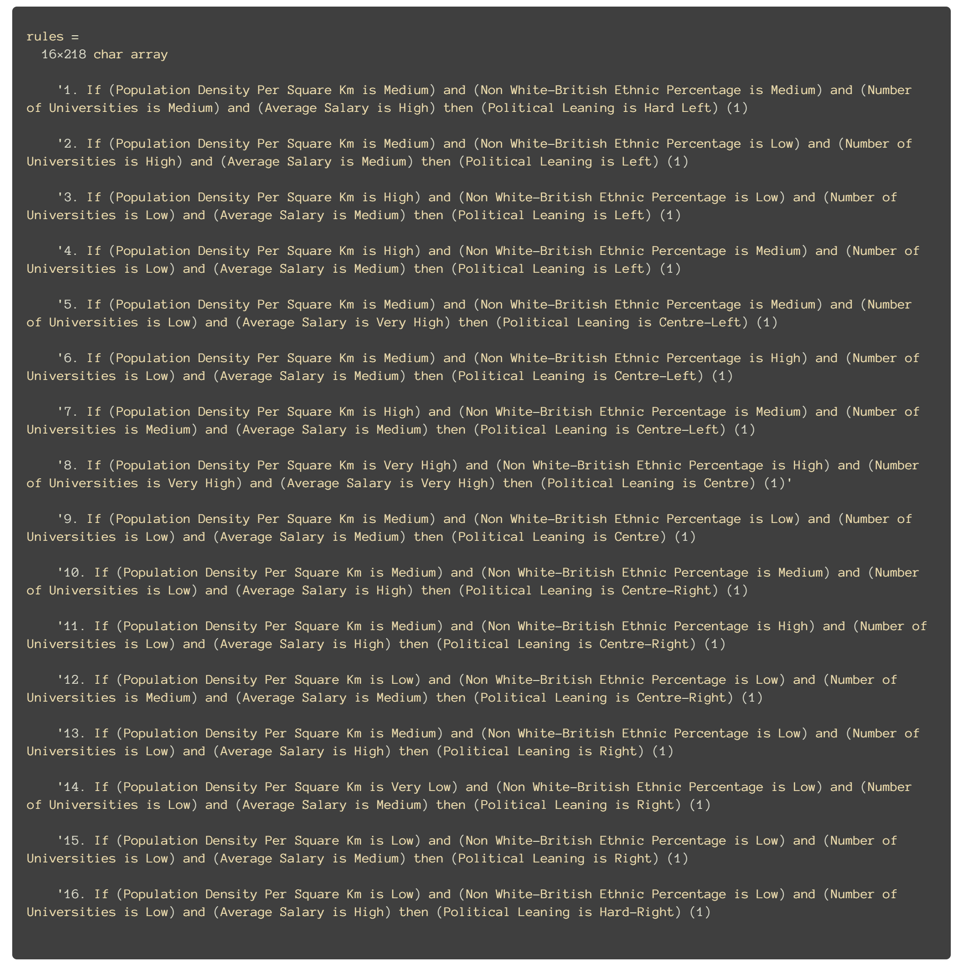

## Fuzzy Set Distribution

**Before Adjustments**

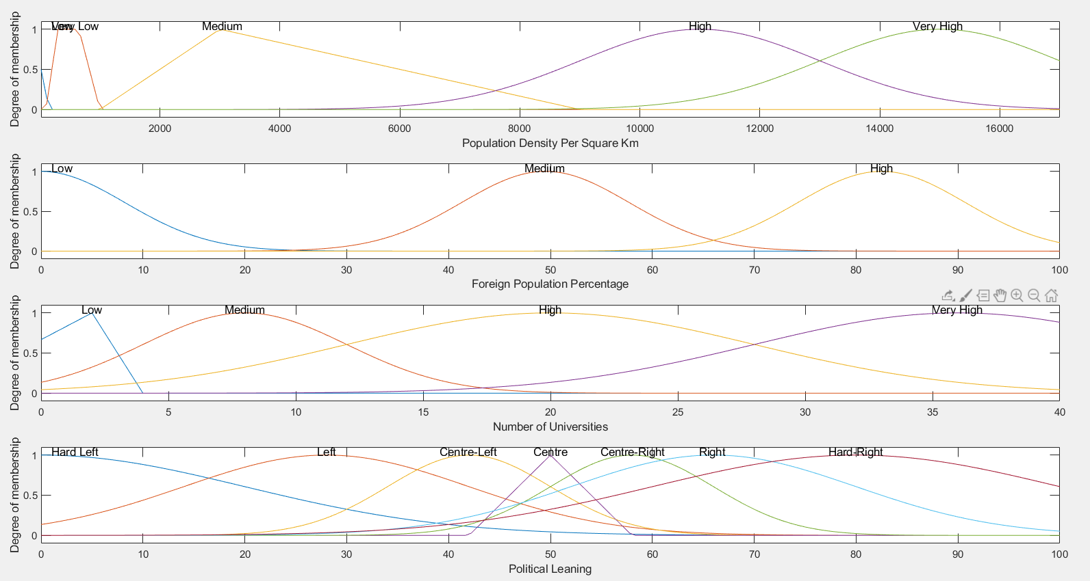

**After Adjustments**

